# How to Create Virtual Products in Magento 2

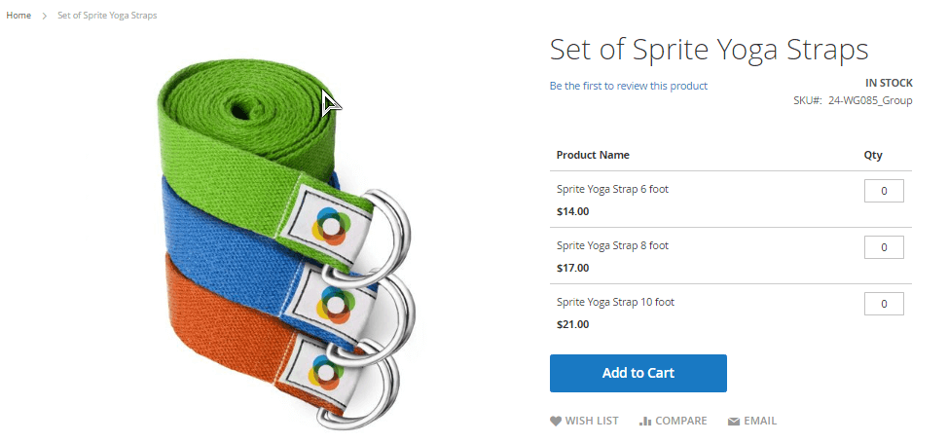

## Virtual Product

A Virtual Product or Digital Product can be used for intangible items such as a membership, service, warranty, or subscription. They can be sold individually or included in grouped or bundled product. Configuring Virtual Product in Magento 2 is the same as Simple Product, but without the weight field or the option to include a gift card.

## How to Create a Virtual Product in Magento 2

### Step 1: Choose the product type

1. On the Admin sidebar, tap Products. Then, choose Catalog.

2. In the upper-right corner on the Add Product menu, choose Virtual Product.

### Step 2: Choose the Attribute Set

To choose the Attribute Set that is used as a template for the product, do one of the following:

* In the Search box, enter the name of the attribute set.
* In the list, choose the attribute set that you want to use.

The form is updated to reflect the change

### Step 3: Complete the Required Settings

1. Enter the product Product Name.

2. Accept the default SKU that is based on the product name, or enter another.

3. Enter the product Price.

4. Because the product is not yet ready to publish, set the Enable Product switch to the “No” position.

5. Tap Save and continue.

When the product is saved, the Store View chooser appears in the upper-left corner.

6. Choose the **Store View** where the product is to be available.

### Step 4: Configure the Basic Settings

**1.**Set **Tax Class** to one of the following:

* None
* Taxable Goods

2. Enter the **Quantity** of the product that is currently in stock. Then, do the following:

a. Accept the default **Stock Status** setting, “In Stock.”

Note that the **Weight** field is not used, because a virtual product is not shipped.

**b.**Accept the default **Visibility** setting, “Catalog, Search.”

**3.**To assign **Categories** to the product, tap the **Select…** box. Then, do either of the following:Choose an existing category:

a. Start typing in the box to find a match.

b. Mark the checkbox of the category that is to be assigned.

Create a new category:

**a.**Tap **New Category**

b. Enter the **Category Name** and choose the **Parent Category** to determine its position in the menu structure.

**c.** Tap **Create Category**

There might be additional individual attributes that describe the product. The selection varies attribute set, and you can complete them later.

### Step 5: Complete the Product Information

* Complete the information in the following sections as needed:
* Content
* Images and Videos
* Search Engine Optimization
* Related Products, Up-Sells, Cross-Sells
* Customizable Options
* Product in Websites
* Design
* Gift Options

### Step 6: Publish the Product

**1.**If you are ready to publish the product in the catalog, set the **Enable Product** switch to the “Yes” position.

**2.**Do one of the following:

**Method 1:**Save and Preview

1. In the upper-right corner, tap **Save**
2. To view the product in your store, choose **Customer View** on the **Admin** menu. The store opens in a new browser tab

**Method 2:** Save and Close

On the **Save** menu, choose **Save & Close**.